# Op Amp Selection for PCB Tester Compatibility

Refer to Fig. 1 and the instructions below when considering which LF347 Op Amps to use in your ECEN 250 daughter Board designs. Following these instructions will ensure that your choice is compatible with our PCB tester. Although not covered in these instructions, you should also consider which Op Amp selection will best simplify routing traces to the header pins.

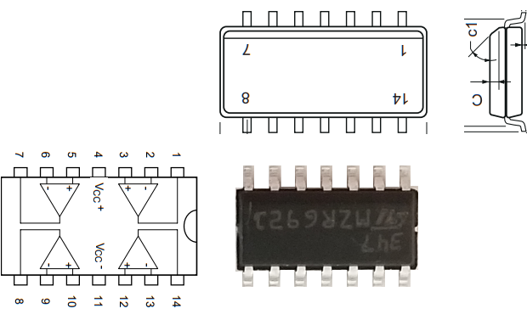

**A**

**B**

**C**

**D**

Figure 1 LF347 Quad Package Pinout

## Buffer Amplifier: Op Amp Choices for PCB Tester Compatibility

1. If **Op Amp A** is chosen for the **Right Channel**, **Op Amp D** must be chosen for the **Left Channel** or vice versa.
2. If **Op Amp B** is chosen for the **Left Channel**, **Op Amp C** must be chosen for the **Right Channel** or vice versa.

Not used

Not used

Right or Left

Channel

Right or Left

Channel

Not used

Right or Left

Channel

Right or Left

Channel

Not used

OR

A

D

B

C

A

D

B

C

Figure 2 Buffer Amplifier: Op Amp Choices for PCB Tester Compatibility

## Microphone & Mixer: Op Amp Choices for PCB Tester Compatibility

1. If **Op Amp A** and **D** were chosen for the **Mic Stage 1** and **Mic Stage 2** respectively or vice versa, **Op Amp B** and **C** must be chosen for **Mixer Right Channel** and **Mixer Left Channel** respectively or vice versa.
2. If **Op Amp B** and **D** were chosen for the **Mic Stage 1** and **Mic Stage 2** respectively or vice versa, **Op Amp A** and **D** must be chosen for **Mixer Right Channel** and **Mixer Left Channel** respectively or vice versa.

OR

Mic_S1 or

Mic_S2

Mic_S1 or

Mic_S2

Mix_Right or

Mix_Left

Mix_Right or

Mix_Left

Mic_S1 or

Mic_S2

Mic_S1 or

Mic_S2

Mix_Right or

Mix_Left

Mix_Right or

Mix_Left

A

D

B

C

A

D

B

C

Figure 3 Microphone & Mixer: Op Amp Choices for PCB Tester Compatibility

## Treble & Bass: Op Amp Choices for PCB Tester Compatibility

1. If **Op Amp A** and **D** were chosen for the **Treble Right Channel** and **Treble Left Channel** respectively or vice versa, **Op Amp B** and **C** must be chosen for **Bass Right Channel** and **Bass Left Channel** respectively or vice versa.
2. If **Op Amp B** and **C** were chosen for the **Treble Right Channel** and **Treble Left Channel** respectively or vice versa, **Op Amp A** and **D** must be chosen for **Bass Right Channel** and **Bass Left Channel** respectively or vice versa.

OR

Trb_Right or

Trb_Left

Trb_Right or

Trb_Left

Bass_Right or

Bass_Left

Bass_Right or

Bass_Left

Trb_Right or

Trb_Left

Trb_Right or

Trb_Left

Bass_Right or

Bass_Left

Bass_Right or

Bass_Left

A

D

B

C

A

D

B

C

Figure 4 Treble & Bass: Op Amp Choices for PCB Tester Compatibility